Final Project Week 1 Test Plan

1. Landing Page



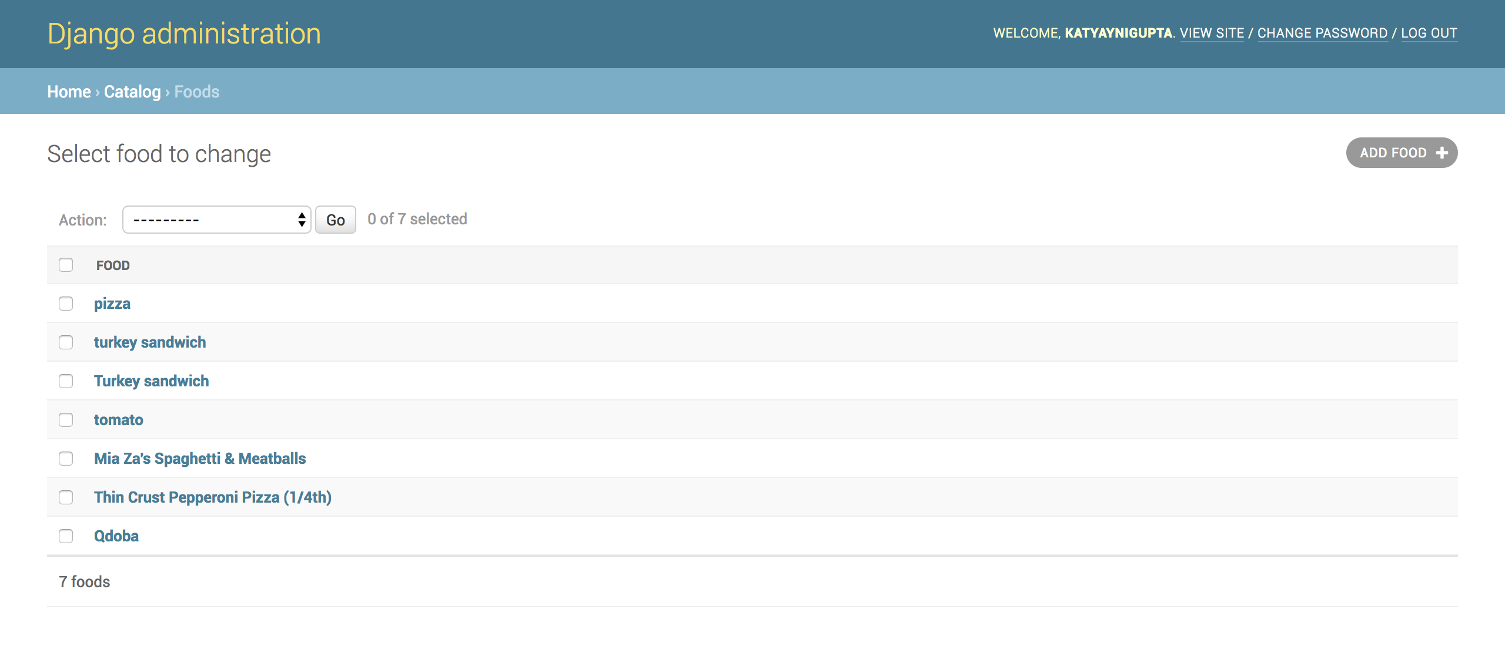

Both shows the same number of foods in the database.

1. Look up an item



1. Results



Shows the previous search with calories and serving size

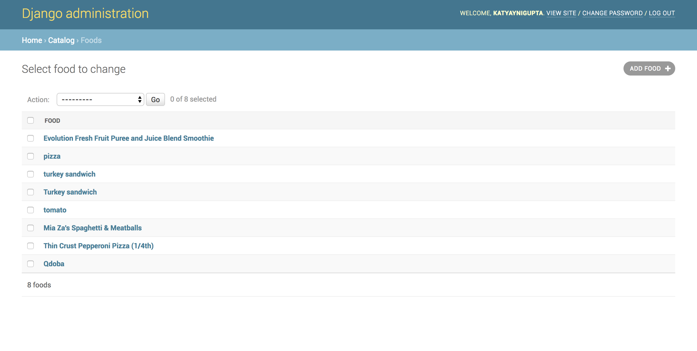

Shows up in the database once searched and the below image shows that the fields are automatically populated.

